2014 Aston Martin Vantage V8

Transmission Oil Change

Summary:
This procedure describes the transmission oil change for a 2014 Vantage V8 Roaster with Sportshift II.
While several posts and videos on Aston Martin forums, YouTube etc. cover the oil change procedure for manual transmissions and older Sportshift versions, I could not find one for this particular vehicle and transmission.

Tools required:
- Equipment to jack up vehicle (lift, jacks etc.)
- Tools to remove wheel
- 3/8in Ratchet
- 13 mm Socket
- 7 mm Allen Socket or Allen Key
- Funnel with cut-off valve
- Funnel stand (anything which can hold the funnel above the oil fill inlet level
- 5ft clear rubber hose (connected to funnel)
- Container for waste oil (min 5l capacity)

Material, Parts required:
- 5l Transmission Oil, Castrol BOT270A (only 4l are necessary, but just in case)
There are several posts addressing potential replacements for BOT270A (Mobil 300,
Castrol Syntrax etc.). While those seem to work well in manual transmissions, I did not
want to take a chance with the Sportshift - the oil change is required only every 4 years/40k mls
after all and the potential price savings are therefore rather small. The biggest problem seems
to finding BOT270A, but Richard from Redpants was as always very helpful and delivered the
oil within a few days.

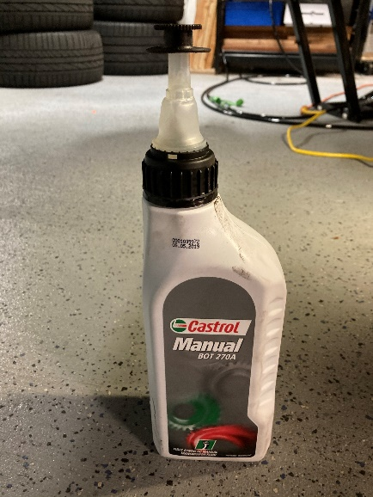

- Transmission Oil drain plug
- Transmission Oil fill plug
- Workshop rugs

Process:
- Engage handbrake

- Remove the two most forward bolts for the rear undertray before jacking up the car.
These bolts are very close to the rear jacking points underneath the car and they will most likely
be covered by whatever lift equipment is used. Removing them before jacking up the car will safe
you lowering the car again, re- attaching the wheel etc.

- Jack up the car
I have a QuickJack car lift and lift adapters from HSM Precision which attach to the jacking points at the underbody – making the whole exercise of jacking up the car very easy.

- Remove right rear wheel

- Remove rear under tray, altogether 21 Bolts (including the two bolts removed earlier)

- Place waste oil container under transmission

- Remove oil fill plug (Allen socket), located on the right side of the transmission above the drive shaft.
Earlier versions of the transmission had an oil fill plug (22mm wrench) just behind the driveshaft. The Sportshift II has an oil level inspection glass where the oil fill plug used to be.
Do not remove the inspection glass plug.

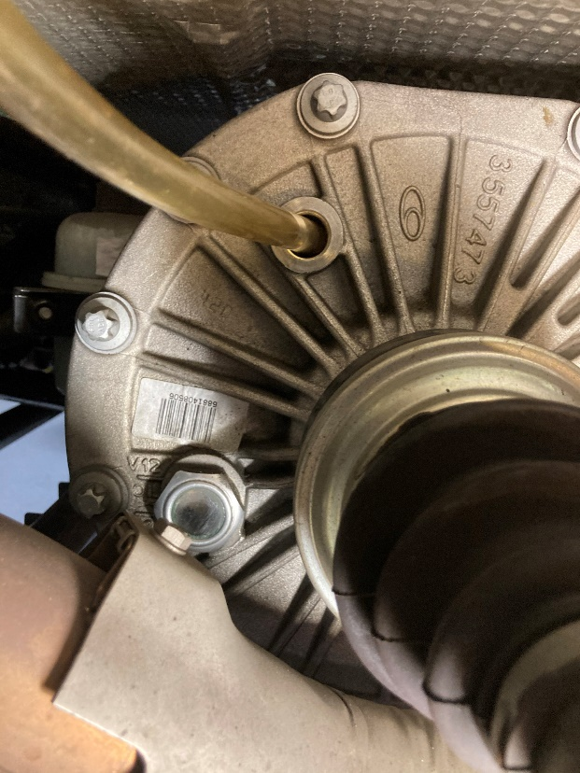
Inspection Glass
Oil Fill

- Remove oil drain plug (Allen socket) at the very bottom of the transmission housing.
Contrary to older transmission versions, the Sportshift II does not have a filter element.

- Let the oil drain for a few minutes
- Install new oil drain plug

- Attach cut-off funnel to a stand and place the stand next to the rear wheel housing.
The bottom of the funnel should be at least 1ft higher than the oil fill plug.
My cut-off funnel had a very fine mesh filter at the outlet. I removed this filter in order to improve
oil flow later.

- Attach the clear rubber hose to the funnel and route it into the oil fill opening.
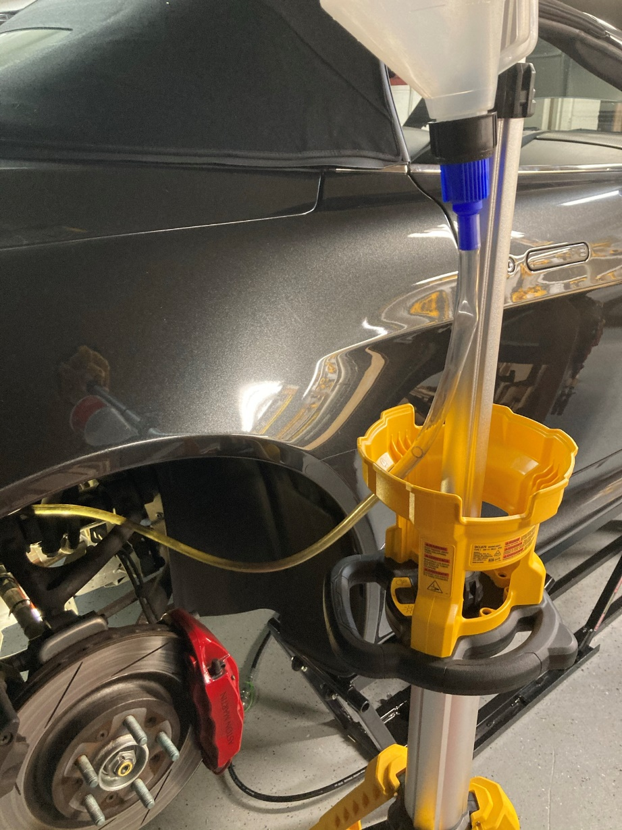
Rubber hose to transm.
Funnel with cut-off valve

- Pour new transmission oil in the funnel and let it flow through the rubber hose into the
transmission. Oil capacity is 4l for a V8 transmission without oil cooler

- Continuously check the oil level through the inspection glass. When the desired oil level is reached close the funnel cut-off valve.
There’re two markings next to the inspection glass. One is at the bottom of the inspection glass and is labeled “V8”, the other one is at the top, labeled “V12”.
I assume that the V12 mark accounts for an additional 0.5l for the transmission oil cooler, which
my car does not have.

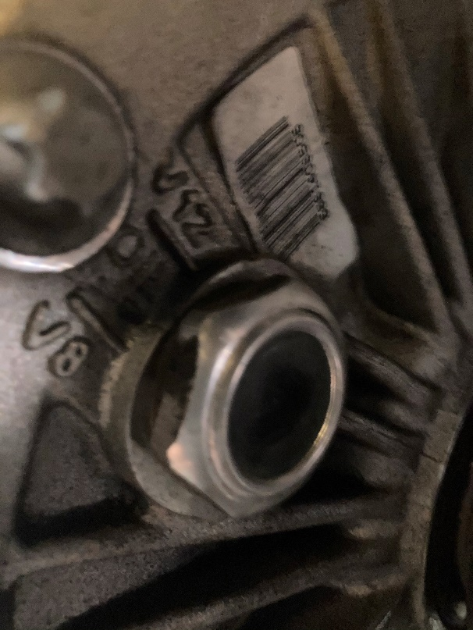
V8 mark
V12 mark

- Let any remaining oil in the rubber hose flow into the transmission and remove rubber hose

- Install new oil fill plug

- Remove waste oil container

- Clean up any oil spill at the transmission

- Wait a few minutes and check for any oil leakage.

- Install undertray (first 19 bolts, do not install two most forward bolts yet).
The thickness of the undertray and the number of bolts used to attach it to the body indicate that it is designed to increase the torsional stiffness of the body – especially beneficial for the roaster.
I therefore recommend to proceed as followed:
- Make sure that the car is levelled (not jacked up on one side only)
- Install first 19 Bolts, do not tighten yet
- When all bolts are installed, torque bolts in an inside-to-outside pattern.
(I used “blue” treat locker and torqued to 25Nm)

- Install rear wheel

- Torque the wheel nuts

- Lower vehicle to the ground, remove jacking equipment

- Install last two bolts for rear undertray (the ones you removed at the very beginning)

